Our project is an analysis of the restaurant industry using [Zomato](https://www.kaggle.com/datasets/rajeshrampure/zomato-dataset) Data. Our client is interested in entering the restaurant Industry. We are helping him by offering valuable insights and recommendations and assisting in their decision-making process. Our specific goal is to find which factors affect the overall rating and foot traffic of restaurants. The data from Zomato provides data involving restaurant rating, cost, number of votes, location, types of cuisines, restaurant type, online order capabilities, and table booking capabilities. There are several charts we implemented in our presentation: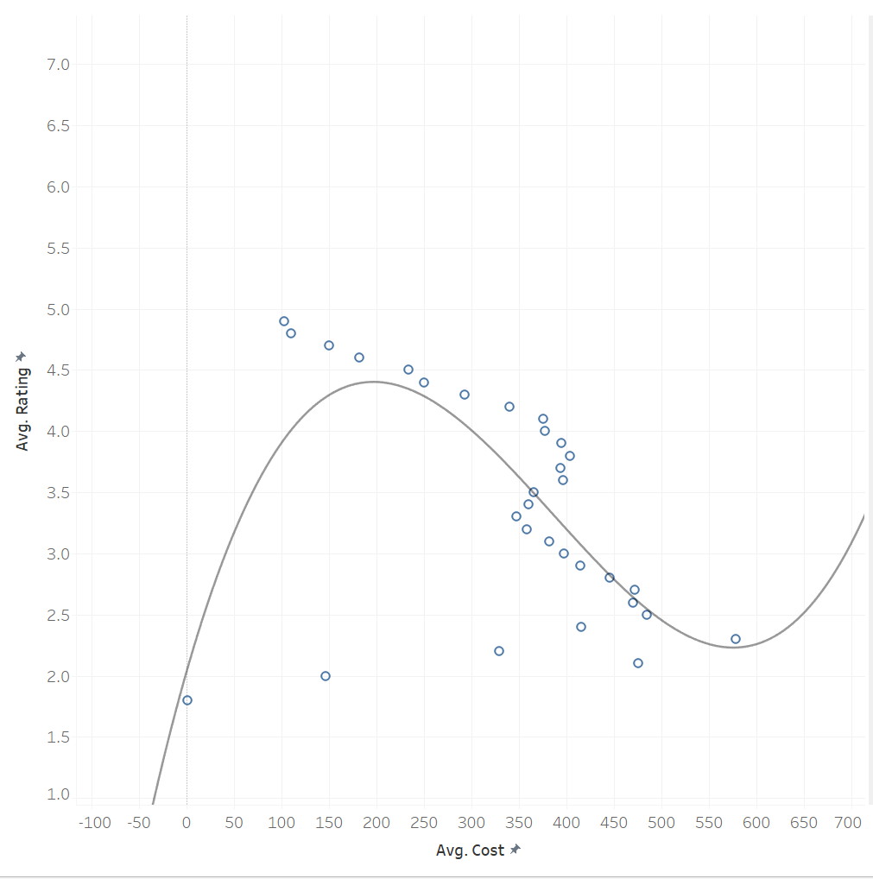

**Correlation of Cost and Rating:** The polynomial correlation between the cost of the restaurant and how the restaurant was rated. The equation found allows us to implement the average cost and calculate a likely rating.

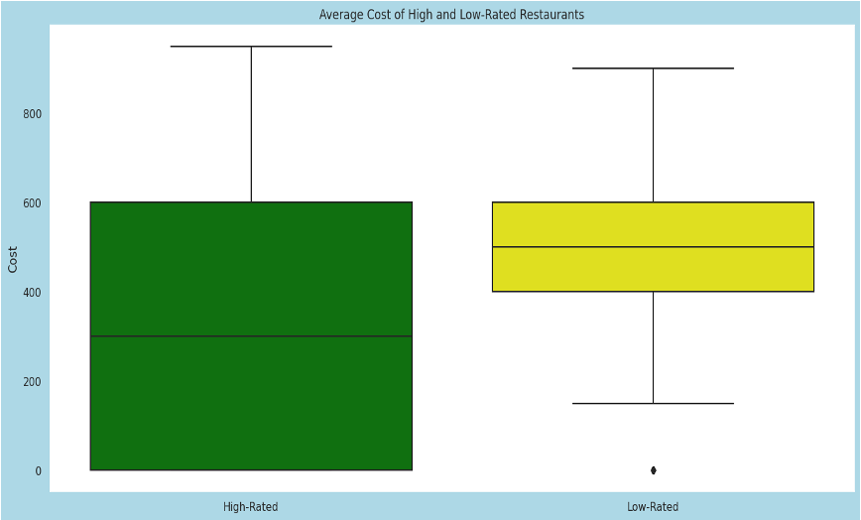

**Cost VS. Rating**:The outcome of this comparison is that High-rated restaurants provide a broader range of prices, which elevate the customer satisfaction, contrarily to lower-rated restaurants that have higher average prices.

**Restaurant Type VS. Rating:** Casual dining, quick bites and cafe are the most popular restaurant types across all ratings, while bakery and food court are the least.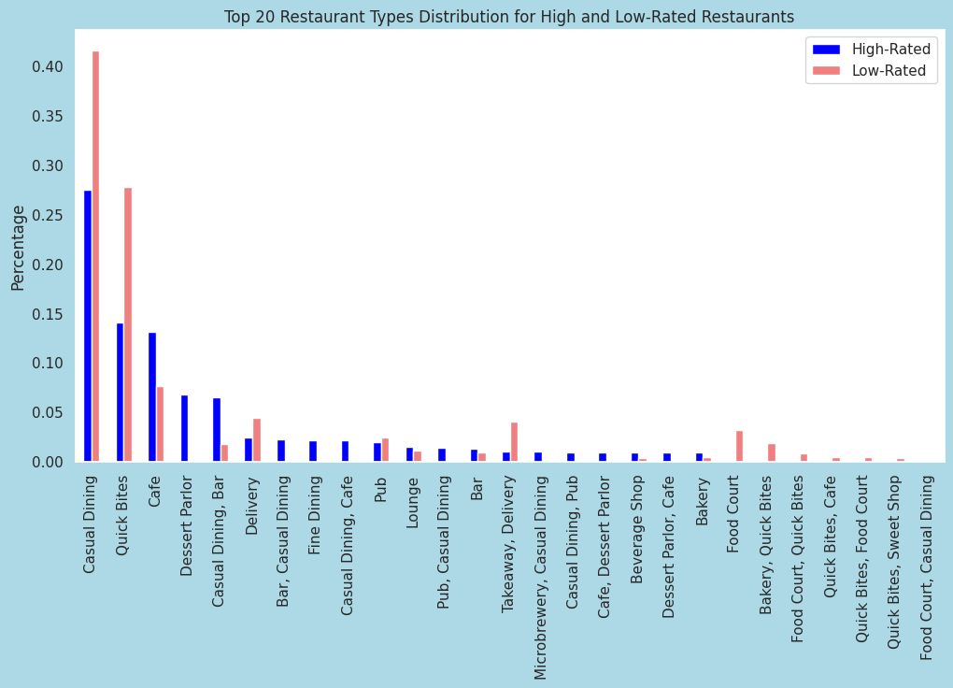

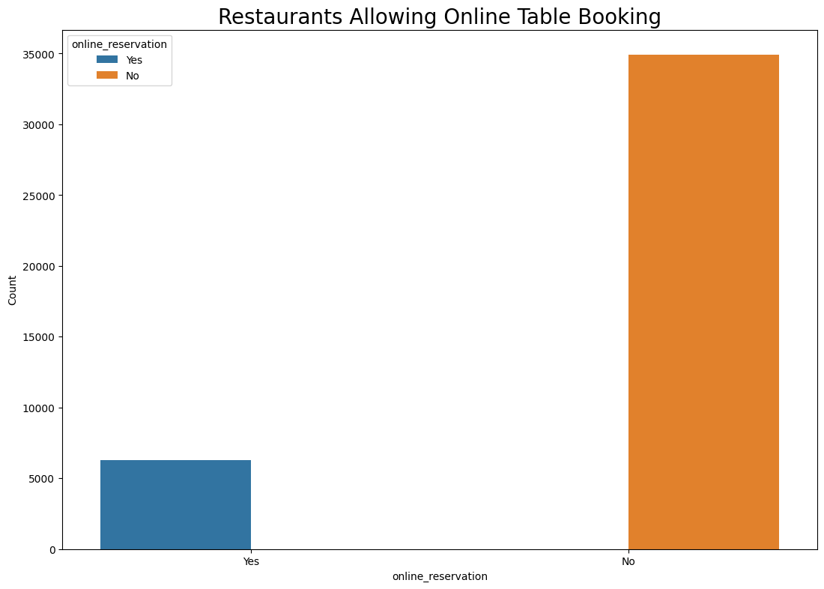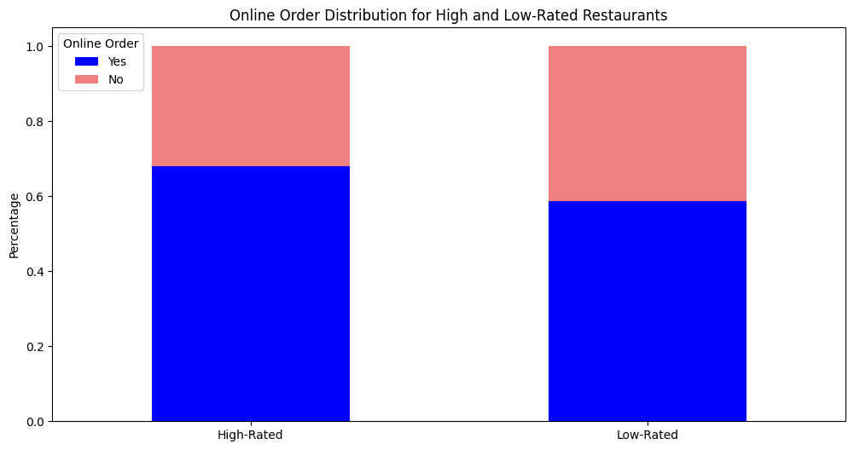

**Online services:** improves customer satisfaction, reviews, business traffic, and over all success, either by making online orders, or booking a table.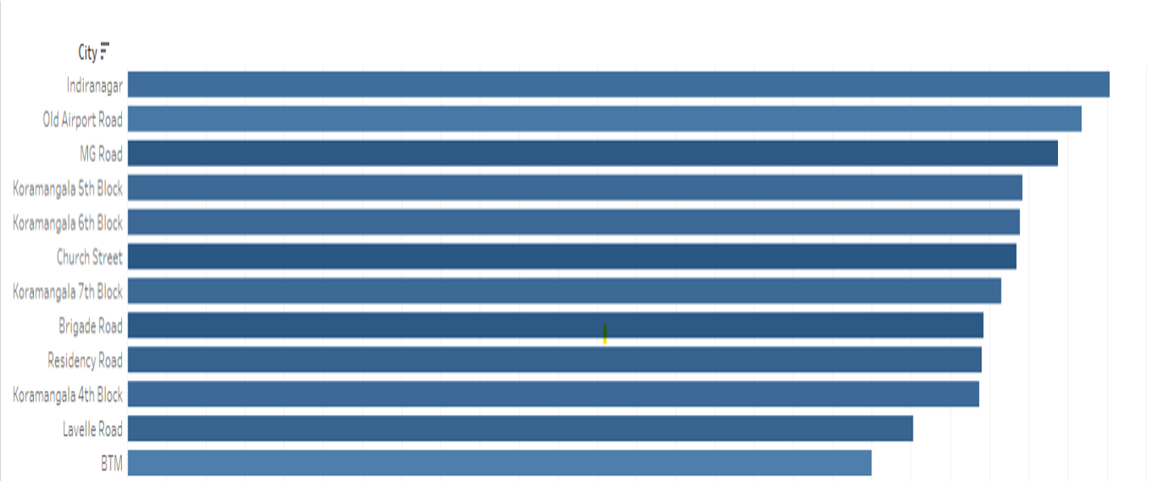

**Average Number of Votes by Street:** ranks the city streets based on number of votes (foot-traffic) with a saturation difference based on average rating.

**Average Number of Votes by Restaurant Type:** ranks the restaurant type based on number of votes (foot-traffic) with a saturation difference based on average rating. 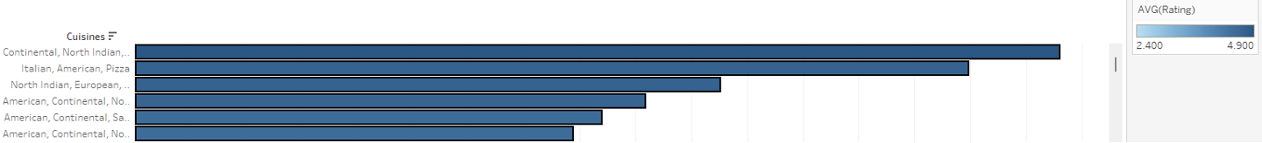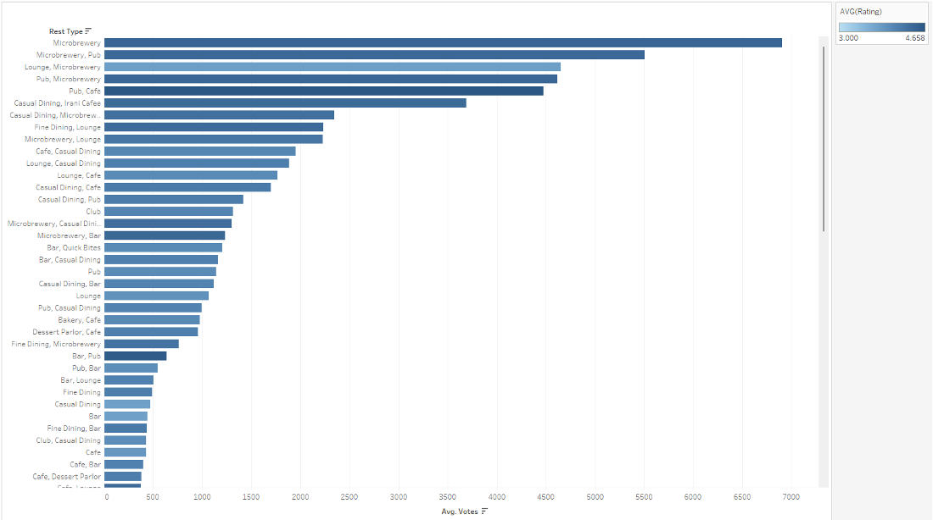

**Average Number of Votes by Cuisine Type :** ranks the cuisine based on number of votes (foot-traffic) with a saturation difference based on average rating.

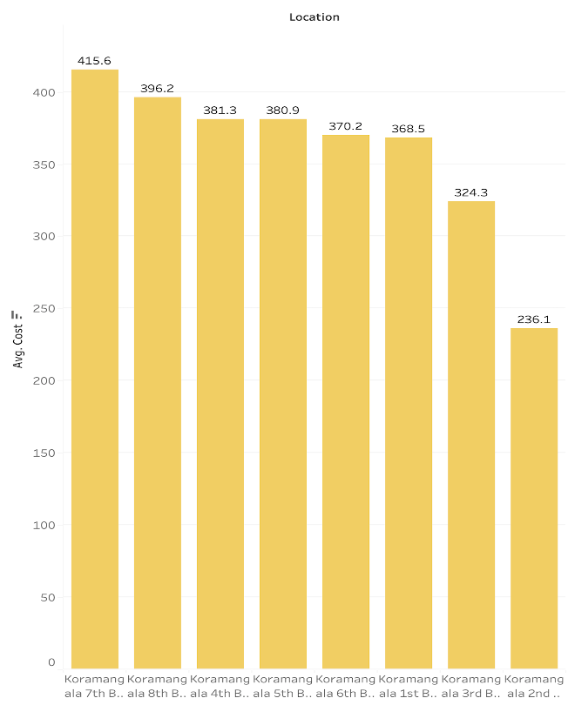

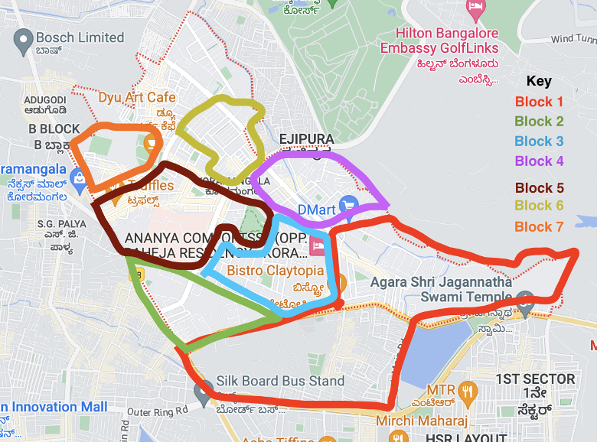

**Average Cost of Koramangala 8 Different Blocks:** This chart provides 8 different blocks in Koramangala. Our goal is to see which block will be the cheapest cost of operation. We can look at the chart and see that Block 2 is the most beneficial for the restaurant owner because it is the cheapest. While Block 7 is the most expensive.

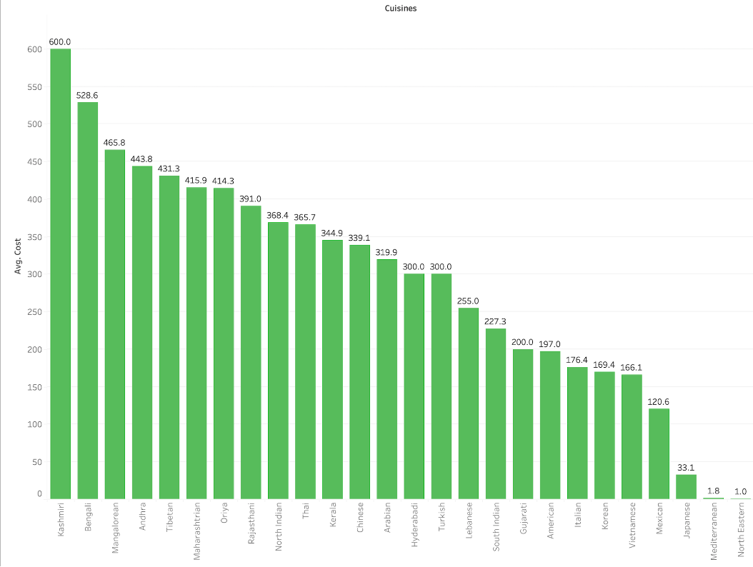

**Average Cost of Different Cuisines in Indian Rupee:** This chart shows the different cuisines average cost in Indian Rupee. We can see that Kashmiri food is the most expensive while North Eastern is the cheapest.

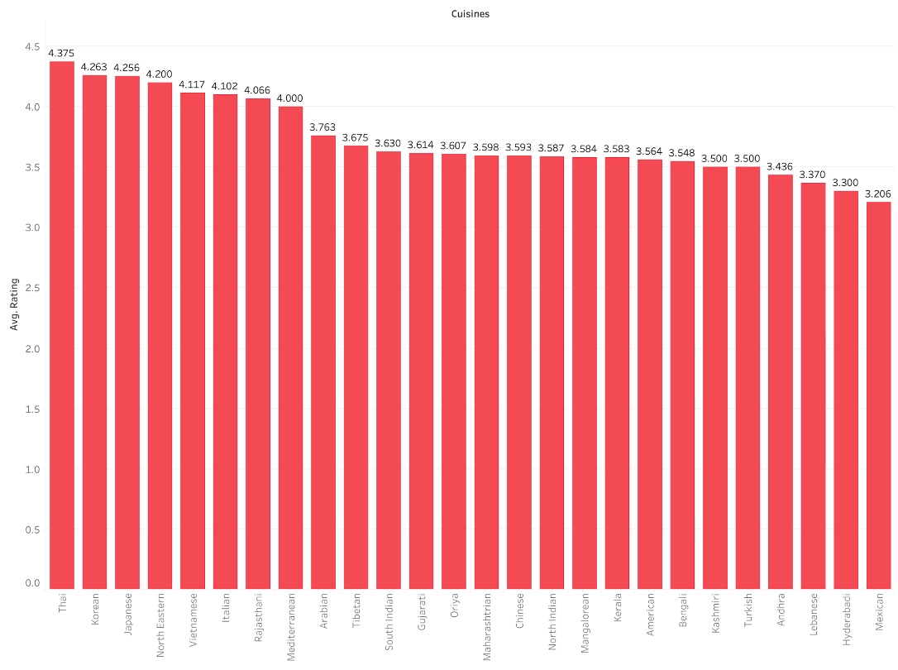

**Average Rating on Different Cuisines:** This chart shows the average rating of the different cuisines. It shows that Thai food has the highest rating while Mexican food has the lowest rating.

Our experience with this presentation was far smoother when compared to our midterm presentation. All of us tried to keep in mind the presentation strategies we learned throughout the semester and especially from the Charismatic Cues video and assignment. While it was difficult to maintain eye contact with the audience because we constantly referred to our data/presentation, we tried our best to establish that connection using hand-gestures and staying off-script to build trust. We also tried to build a connection with the audience, by emphasizing our effort in the first 7 seconds, as well as using vocabulary that the audience is familiar with and avoiding negative body language blockers that we learned in class.

This semester we have learned about many different data visualization techniques. We studied Tableau, Vega-Lite, and ggplot. We also studied how AI is advancing and becoming the future of data visualization. Something we found very helpful was a deep dive into Tableau, Tableau is a software that is universal in the business world. Tableau makes creating data visualizations easy and makes presenting data to others easier than ever. We think the topics covered were very interesting, a suggestion might be to create a project for the students to use ChatGPT and some of the other new AI services being released. Studying AI was very enjoyable, it would be fun and interesting to have the students get hands-on experience using these services as they will be used in their future careers.